public class Question1 {
public static void main(String[] args) {
// TODO Auto-generated method stub
// System.setProperty("webdriver.edge.driver", "C:\\Users\\karthikmo\\executable file\\New folder\\msedgedriver.exe");
//
// WebDriver driver = new EdgeDriver();
System.setProperty("Webdriver.gecko.driver", "C:\\Users\\karthikmo\\executable file\\geckodriver.exe");
WebDriver driver = new FirefoxDriver();
driver.get("https://demoqa.com/automation-practice-form");
driver.manage().window().maximize();
WebElement firstname = driver.findElement(By.id("firstName"));
firstname.sendKeys("Karthik");
WebElement lastname = driver.findElement(By.id("lastName"));
lastname.sendKeys("Mohan");
WebElement gender =driver.findElement(By.xpath("//label[text()=\"Male\"]"));
gender.click();
WebElement usernum = driver.findElement(By.xpath("//input[@id='userNumber']"));
usernum.sendKeys("8610053454");
WebElement dob = driver.findElement(By.id("dateOfBirthInput"));
dob.click();
driver.findElement(By.xpath("//div[@aria-label=\"Choose Tuesday, February 6th, 2024\"]")).click();
//
// WebElement Sub = driver.findElement(By.id("subjectsContainer"));
//
// Sub.click();
// Sub.sendKeys("Maths");
//driver.findElement(By.xpath("//input[@id='hobbies-checkbox-1']")).click();
driver.findElement(By.xpath("//input[@id='uploadPicture']")).sendKeys("C:\\Users\\karthikmo\\Documents\\SQL tables diagram\\ERD.png");
driver.findElement(By.xpath("//textarea[@id='currentAddress']")).sendKeys("test test test");
WebElement state =driver.findElement(By.xpath("//div[@id='state']"));
// state.click();
//state.findElement(By.xpath("//div[text()='NCR']"));
WebElement submitbutton =driver.findElement(By.id("id='submit']"));
JavascriptExecutor js = (JavascriptExecutor) driver;
js.executeScript("arguments[0].scrollIntoView(false);", submitbutton);
submitbutton.click();

public class Question2 {
public static void main(String[] args) {
// TODO Auto-generated method stub
System.setProperty("Webdriver.gecko.driver", "C:\\Users\\karthikmo\\executable file\\geckodriver.exe");
WebDriver driver = new FirefoxDriver();
driver.get("https://demoqa.com/alerts");
WebElement clickmElement = driver.findElement(By.id("confirmButton"));
clickmElement.click();
Alert alert = driver.switchTo().alert();
alert.accept();
}

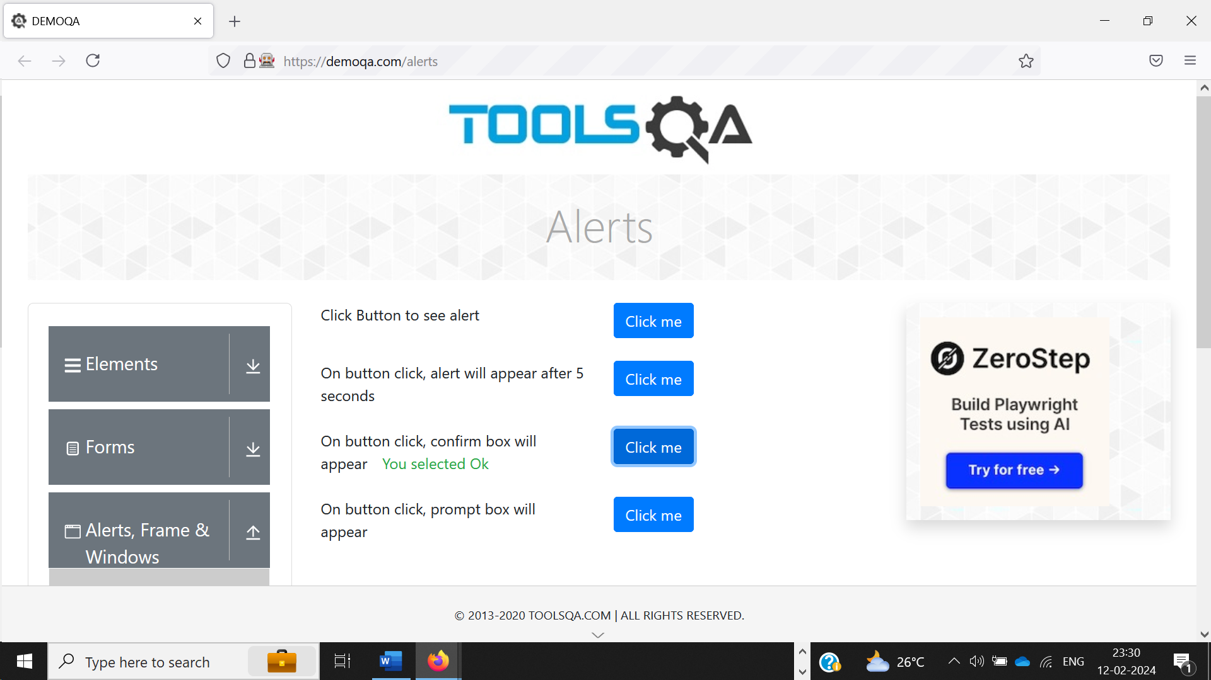

public class Question3 {
public static void main(String[] args) throws IOException {
// TODO Auto-generated method stub
System.setProperty("Webdriver.gecko.driver", "C:\\Users\\karthikmo\\executable file\\geckodriver.exe");
WebDriver driver = new FirefoxDriver();
driver.get("https://demoqa.com/browser-windows");
String parentwindow = driver.getWindowHandle();
driver.findElement(By.xpath("//button[@id='tabButton']")).click();
Set<String> eachwindow = driver.getWindowHandles();
for(String newtab:eachwindow) {
if (!newtab.equals(parentwindow)) {
//System.out.println("this is not parent window");
driver.switchTo().window(newtab);
//System.out.println("this is parent window");
}
}
File snap = ((TakesScreenshot)driver).getScreenshotAs(OutputType.FILE);
File dest1= new File("C:\\Users\\karthikmo\\Screenshot\\img2.png");
FileUtils.copyFile(snap, dest1);
}
}

public class Question4 {
public static void main(String[] args) {
// TODO Auto-generated method stub
System.setProperty("Webdriver.gecko.driver", "C:\\Users\\karthikmo\\executable file\\geckodriver.exe");
WebDriver driver = new FirefoxDriver();
driver.get("https://demoqa.com/frames");
driver.switchTo().frame("frame1");
WebElement Text = driver.findElement(By.id("sampleHeading"));
String text = Text.getText();
System.out.println("Frame1 " + text);
driver.switchTo().defaultContent();
driver.switchTo().frame("frame2");
WebElement findElement2 = driver.findElement(By.id("sampleHeading"));
String text2 = findElement2.getText();
System.out.println("Frame 2 " + text2);
}
}

